Dear Parent/Guardian,

Culver Community Schools Corporation will be conducting online Registration for the upcoming 2020-2021 school year beginning July 10th. On-site registration will be July 28th, 29th, 30th from 12pm-7pm.

To assist with online registration, please follow along with these instructions:
Please go to: https://harmony.culver.k12.in.us/familyaccess.nsf/hello.xsp
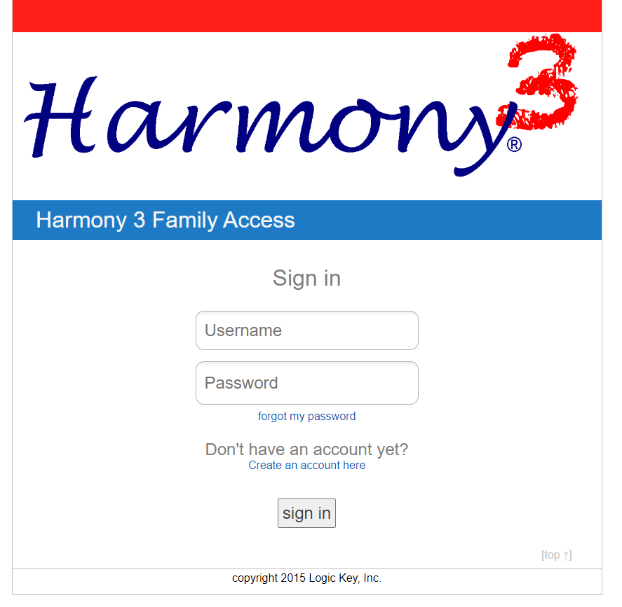
- Login with your Parent/Guardian account. Do NOT use your student’s account, it will not let you register.

If you have forgotten your username or password,
Username: Click “Create an account here” and contact the office for your new code.
Password: On the Harmony sign in page, please select the “forgot my password” blue link. This will allow you to send a password reset request to your email address.

Once you are successfully in your guardian/parent account, you may skip to step 3
- If you do not have an account set up yet, please select the “Create an account here” blue link From there, you will first enter in all of your guardian/parent information, you can select “register”.
Please be aware, that “register” in this matter does not mean register for the 2020-2021 school year enrollment. This just means you are registering yourself as a parent, for a parent Harmony account.
- It will ask you next for a “Registration Code” for your student(s). Please call your child’s building secretary or you may also email ddaugharty@culver.k12.in.us and either one would be able to provide you with your child’s registration code.

You will need this code to link your child(ren) to your Parent/Guardian account. Again, please note that this registration code, DOES NOT register that child for enrollment, it only “registers” the child as a student under your guardian/parent account.

- Once you are successfully into your parent account, and have successfully linked your child(ren) to your Parent/Guardian account, you may then begin the actual enrollment registration process:
  - Once you have signed into your account, you should see your child(ren)’s name(s) across the top allowing you to toggle back and forth between children (if applicable).
    - If you are missing a child on your account, please call your child’s building secretary or email ddaugharty@culver.k12.in.us and either one would be able to give you the student code to link that child to your parent account.
  - Select the first student you would like to enroll and begin scrolling towards the bottom.
  - Towards the mid-bottom portion of your screen, you will have a list of items under a header “online registration”.
  - Everything that is not yet marked with a green check mark, will need to be selected and completed.
    - Please be aware, there are a few (depending on which building your child is in) that are optional, you are not required complete the optional forms.

- Once you have completed all online registration items (except for potentially the ones that say they are optional), and you have green check marks for all necessary items, you then have completed all necessary steps to enroll that child.

- Please repeat the steps over for any additional children you may have or wish to enroll. There is no way to mass enroll siblings; you must do each child one at a time.

If you have any questions or trouble, please contact the schools.
Culver Community Administration Office (574)-842-3364
Culver Elementary School (574)-842-3389
Culver Middle/High School (574)-842-3391

